**CHE517 ADVANCED PROCESS CONTROL**

**FINAL EXAM**

Professor Shi-Shang Jang Jan. 14, 2015

**Problem #1 Interpretation: (20%)**

(1) Multi-input/Multi-output (MIMO)

1. Decoupling
2. Feedforward Control
3. Cascade Control
4. First-Order Hold

**Problem #2 (20%)**

Consider the jacketed continuous stirred tank reactor (CSTR) sketched in the following Figure. The following information is obtained from testing the reactor and its control system: The transfer function of the reactor temperature to the jacket temperature is first-order lag with a gain of 0.6。C/。C and a time constant of 13 min. The transfer function of the jacket temperature to the coolant flow is a first lag with a gain of -2.0。C/(kg/s) and a time constant of 2.5 min. The control valve is linear with constant pressure drop and is sized to pass 12 kg/s when folly opened. Its time constant is negligible. The jacket temperature transmitter is calibrated for a range of 0 to 100。C, and its time constant is negligible.

1. Decide on the proper fail position of the control valve loop. Draw the block diagram showing all transfer functions and write the closed-loop transfer function of reactor temperature to its set point. Pay particular attention to the signs which must correspond to the fail position of the valve and the controller action.
2. Write the characteristic equation for the single feedback loop and calculate its ultimate gain and period by direct substitution.
3. Design a cascade control system for the reactor temperature with the jacket temperature as the intermediate process variable, specifying the action of both controllers. Draw the complete block diagram for the cascade control system showing all transfer function and their signs. 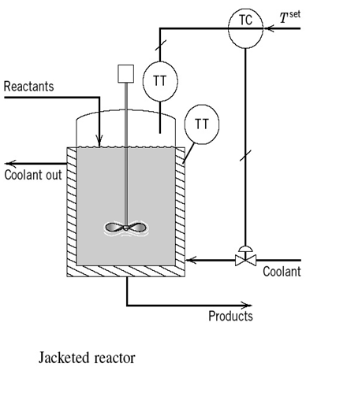

Problem #3 (20%)

(a) Develop a feedforward-feedback control system for a process with the following transfer functions;



The following specifications are also given: (1) use a PI controller for the feedback loop, and (2) the feedforward system should have both disturbance rejection and set point tracking capabilities.

(b) Show how would tune the feedback PI controller.

(c ) Derive the conditions that must be satisfied in order to have stable closed-loop response. Do these conditions depend on both feedforward and feedback characteristics?

**Problem #4 (20%)**

Derive the discrete transfer functions of the following open-loop systems with a zero order hold(sampling time=0.5):

(1) $G(s)=\frac{e^{-s}}{{4s}^{2}+3,6s+1}$



(2)

**Problem #5 (20%) Take home**

Consider the following hot-water-cold water system with the following parameters:

A=1m2;

(1) Derive the energy and material balances equations

(2) Write a M-file code to simulate the dynamic system with sampling time of 1minute.

(3) Perform dynamic simulation of process control of the multivariable system by assuming a step change of level set point by increasing to 5m with two individual controllers all with Kc=1, τI=1min.

(4) Dervie all transfer functions using step response approximation and draw the plant block functions. Also derive the decoupling system for the plant.

(5) Perform dynamic simulation of process control with decoupling by assuming a step change of level set point by increasing to 5m with two individual controllers all with Kc=1, τI=1min.

(6) Compare the results in (3) and (5).

